SPRINT-3

|  |  |
| --- | --- |
| TEAMID | PNT2022TMID08747 |
| ProjectName | IoTBasedsmartcropProtectionsystemforagriculture |
| Maximummark | 20marks |

STEP1:Simulatedprogramtogettherandomvalues.

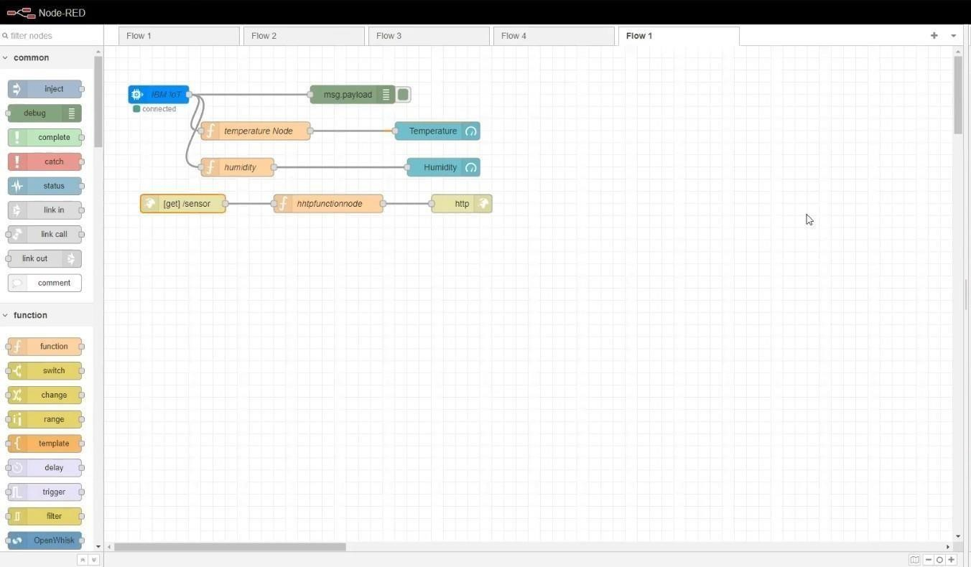

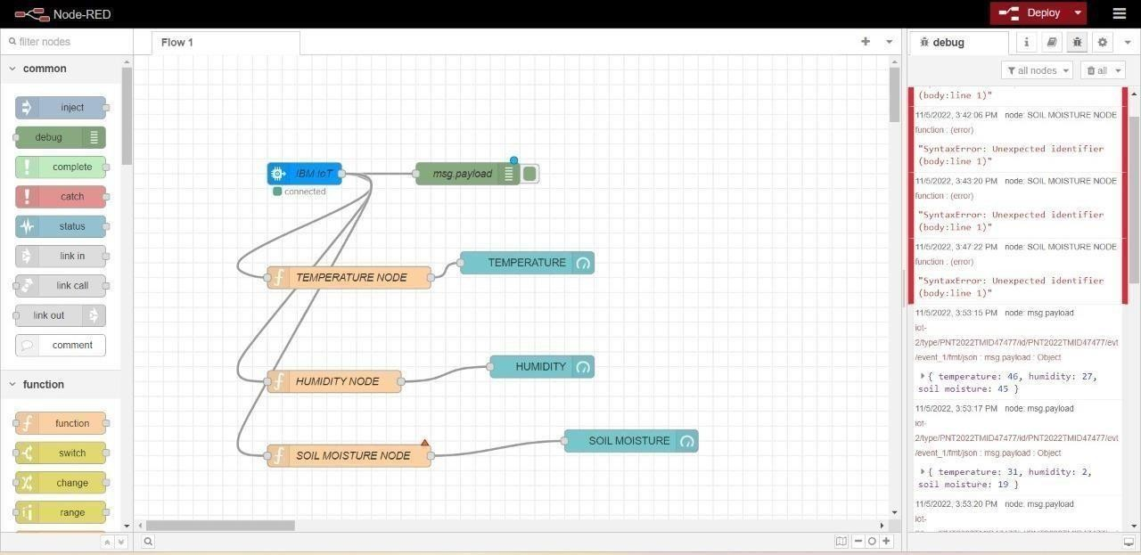

STEP2:GeneratedebugmessagefromIBMWatsonIoTPlatformandconnectthenodes.STEP3:Generatethesomeoutput from recentevents.

